Pirates, Scoundrels, and Kings
By William Lynes

Pirates, Scoundrels, and Kings (PSK) is a fantasy/ adventure story, set in the medieval kingdom of Alucemet (Temecula spelled backward). It is intended for the young and adult audiences. It is a 120 K word, 404-page work of fiction. It is divided into three volumes, Pirates (I), Scoundrels (II), and Kings (III).

The protagonist, Christopher of Temecula, has had a horrible Monday at school, characterized by falling in the mud, pop quizzes, and a harrowing bus ride home, driven by a maniacal pig-like man named Hurley. After a disagreement with his two younger brothers, an argument and lightning bolt from a huge cloud sends him to Alucemet. Here he meets a Robin Hood like band of boys called the Pitlings, led by an unassuming Sir Alexander. When he meets an aggressive pirate-boy, Nicholas the Blue, adventures, fun, and a battle for the kingdom begin.
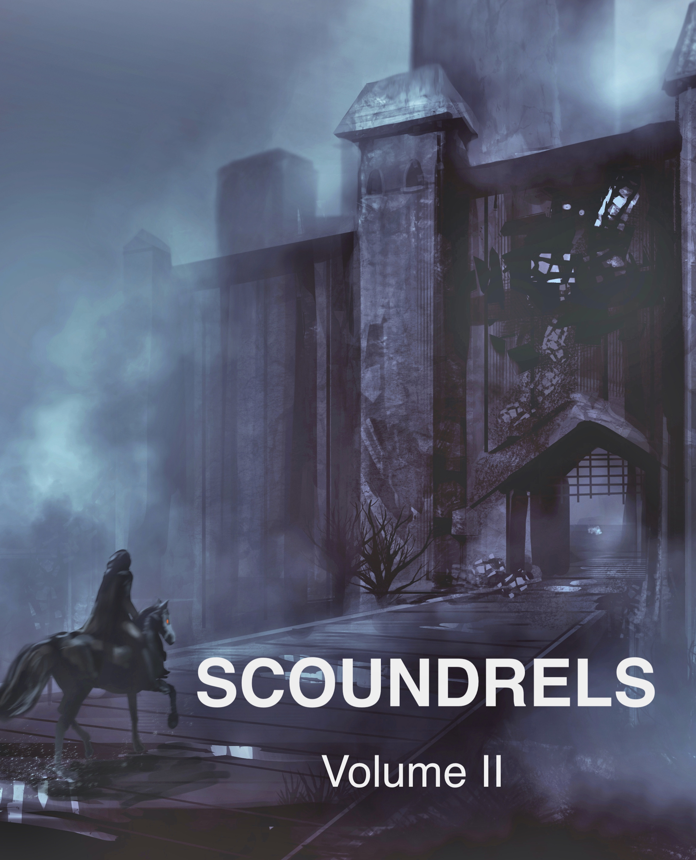

The novel is full of interesting characters from a beautiful queen Patrice, an evil boar called Michaelis, who controls the kingdom, to a pirate named Balaam who suffers from bronchiectasis, a severe respiratory illness. Magical bulldogs, a tormented female apparition, a brilliant rainbow-colored parrot, a magical gum tree, and an evil military man named Fordem dominates the piece. PSK is complete with sword fighting, cannon blasting, pirate ship sailing, and battles for the kingdom.

The overlying theme of faith is woven throughout the novel. The story chronicles a young boy’s maturation from a selfish 10-year-old to an introspective mature boy. The kingdom is in disarray. An evil force controls destiny. Sir Alexander and Nicholas the Blue, with Christopher’s help, battle the evil to restore their royal lineage. It is a tale where faith in God is demonstrated, seriously affecting the boy.

PSK is a story for all ages. It is a quick paced saga of royal intrigue, betrayal, and eventual redemption. Based on the 2012 novel of the same name:
https://www.lynesonline.com/pirates-scoundrels-and-kings.php.
PSK is now a trim, easily read, fantasy/adventure novel for all age groups.

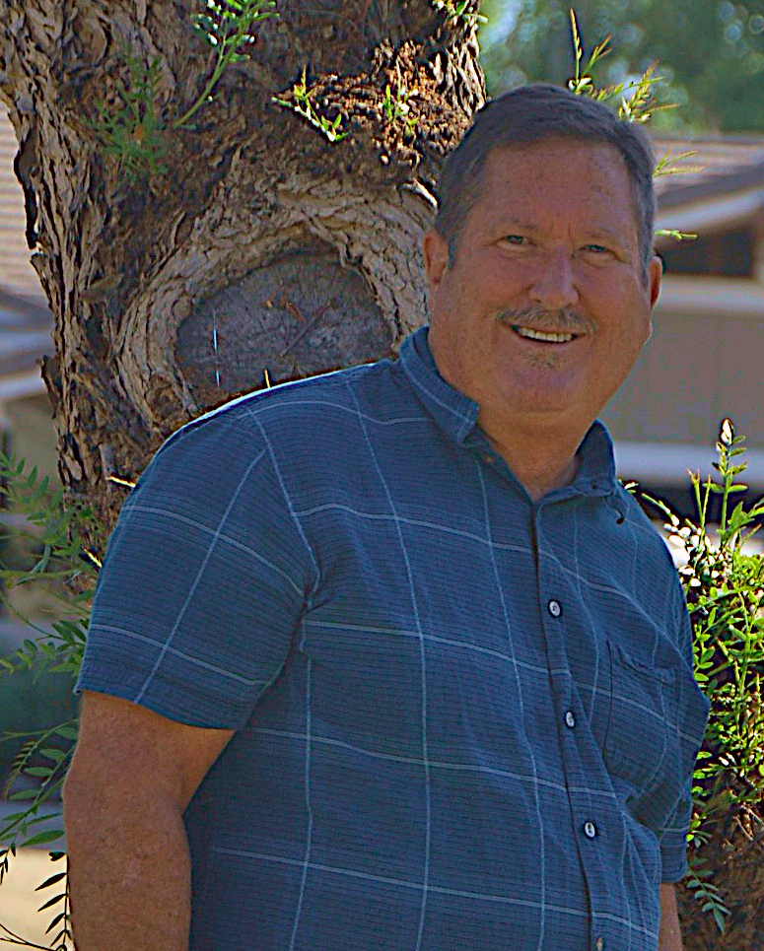

William Lynes, MD (1953-present) is a Stanford trained, Board Certified, retired physician. While in private practice, he suffered two life-threatening illnesses requiring intensive-unit care, each providing inspiration for his first novel, Luger Rounds. His family are the inspiration for his fantasy adventure story Pirates, Scoundrels and Kings. His four Lee W Hickok novels, 606 University, Sweet Amber, The Plumber and Huntsville are medical genre novels. A Surgeon’s Knot is his most recent published work. His wife, Patrice, and he have three grown children and live in Temecula, California.

