
WELCOME TO THE LYNESONLINE NEWSLETTER
I am a Physician, a Urologist, and a Physician Advocate.
My passion is writing. I love to write fiction and specialize in writing medical noir dramas in the form of novels and short stories.
I also write, speak, and advocate on the subject of physician burnout and suicide.
Let me tell you what has been happening over the last few months at LynesOnLine.Com.


My latest published novel is The Old Doctor.
In his 68-year medical career, Elmer Joseph Whatley, MD, has practiced psychiatry longer than most of his colleagues have been alive. Now 94, he questions his ability to continue, yet his dedication to medicine never falters.
He has witnessed overwhelming sadness — his family's suffering during the 1980s HIV/AIDS epidemic, and the toll of severe mental illness on those he loves. A flawed man, he often leans on pharmaceutical solutions for everyday problems, and though devoutly faithful, his beliefs have been tested.
Through loss and misfortune, he confronts his shortcomings, keeps practicing medicine, and finds strength in his faith.
What I am Working On
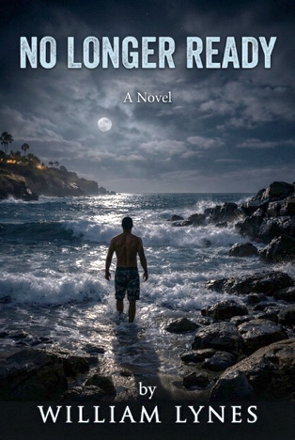
No Longer Ready.
Urologist David Ashford has it all—Stanford pedigree, a thriving La Jolla practice, a loving family—until a wrongful accusation and his own unraveling collapse it in one terrifying night. Saved from suicide by his wife, David is thrust into a world he never imagined: psychiatric wards, mandatory therapy, a physician diversion program monitoring his every move. To practice medicine again, he must prove himself to a wary hospital committee, a suspicious colleague, and, hardest of all, his own children. No Longer Ready is a raw, redemptive story about what it costs a healer to admit he needs to be healed.
Down the Laundry Shoot.

​In this sequel to Pirates, Scoundrels, and Kings, four-year-old Nicholas discovers his bedroom's laundry chute leads not to the wash but to Alucemet, a medieval kingdom of pirates and peril, he and his brothers Chris and Alex are drawn one by one through the dark passage. What begins as sibling squabbles over a lost Ninja Turtle figurine becomes a shared secret: a world of ships, sword fights, and unlikely allies waiting just beyond an ordinary door. As the brothers venture deeper into Alucemet, they're pulled into its gathering conflict, standing together against the kingdom's darkest threat. Some adventures start with nothing more than a staircase.

A Surgeon’s Reckoning-A Trilogy
A Surgeon’s Reckoning is a collection of three novels portraying the life of a troubled surgeon. These three novels stand alone, but can be read as a trilogy. They are not scheduled for publication as yet.
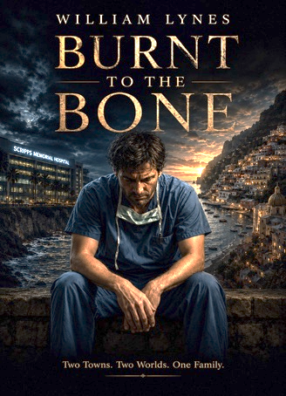
BURNT TO THE BONE
On a January night in 1990, La Jolla surgeon Michael Geller puts a gun to his chest in his office at Scripps Clinic. He survives — barely — and the novel moves backward to reveal how he arrived there.
Three years earlier, fresh from his UCLA chief residency, Michael falls for Elena Rossi, an Italian immigrant and painter whose faith he doesn't share. But surgery has its own appetite: hundred-hour weeks, cocaine, Percocet — all of it accumulating while Elena's love runs up against a husband who's somewhere else even in the room. The preventable death of an eight-year-old patient becomes the wound he can't operate his way out of.
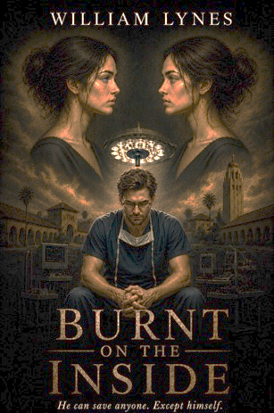
Burnt on the Inside
Louis Sarratt is a Stanford surgical resident burning through hundred-hour weeks on alcohol and Percocet when his career and his marriage to Rhiannon Gwilym collapse at once. A suicide attempt lands him in Stanford's own psychiatric unit, and the novel traces what it takes to rebuild — therapy, a bipolar diagnosis he must learn to say aloud, and a slow return to the OR under the weight of everyone who knows what happened.
Their marriage survives a miscarriage and old wounds before Louis trades academic ambition for a quieter country practice in Walnut Creek — and Rhiannon's news that she's pregnant again.

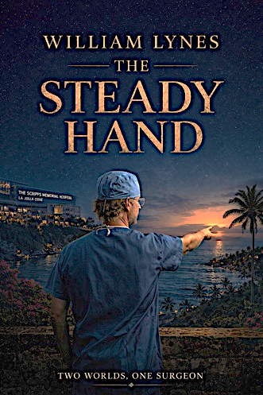
THE STEADY HAND
In March 2000, the California Medical Board strips Dr. Thomas Aldren of his surgical privileges — a tremor from multiple sclerosis, hidden behind will for years, finally can't be trusted with a scalpel. What follows is the unraveling of a man who doesn't know how to be anything but a surgeon, as his marriage to Katherine frays and his daughter Hannah becomes both ally and conscience.
A medical mission to Santa Clara, Cuba, shows Thomas what his hands are still for — but grand rounds applause gives way to private collapse, a DUI, and children who show up anyway.



